Writing your conclusion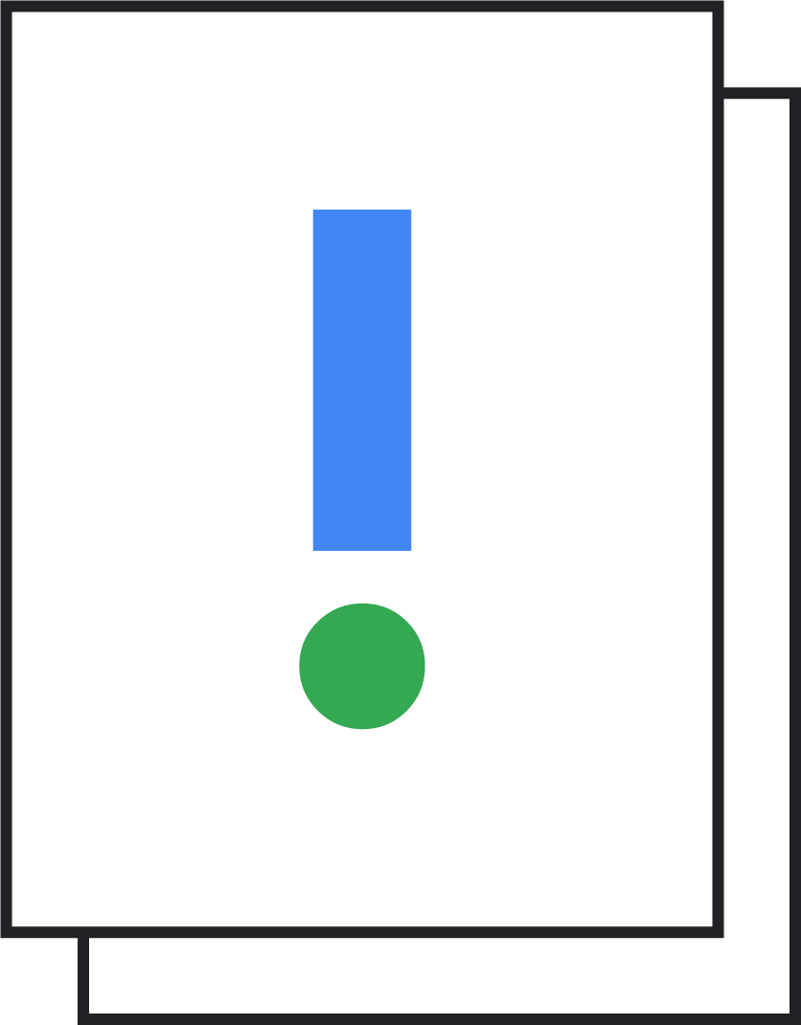

To create a good conclusion, you have your structure of results + solution, but you should reflect back on your work and look ahead to what you could do next.

**What would I have done differently?**

If you could do the project again, would you go about it exactly the same way?

**Has this brought up any new ideas or insights?**

Is there something else you want to explore? Did the results also give a new and interesting understanding? Has feedback from peers provided new insights?

**What are my next steps?**

What are you going to do next? Prioritizing steps is a good way to make sure they actually happen!